M | MOVEMENT/AMBULATION  - Week #1-Short frequent walks around the home  - Week #2-4 Gradually increase distance, starting on level ground  - Use the walker until no longer needing any support and no limp | 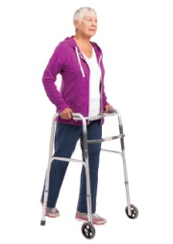
E | ELEVATE  - Elevate your surgical leg whenever resting (bed, chair or couch)  - Sleep elevated on pillows at night, unless it keeps you awake  - DO NOT keep the leg hanging down >30 minutes at a time | 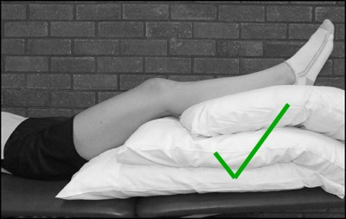
R | REST  - Rest in between walking and daily activities  - Get a good night’s sleep-important for healing!  - Sleep on your back with leg elevated, or sleep on your non-operative side with pillow between the knees | 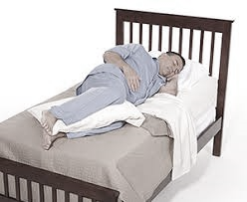
R | ROM-Range of Motion  - Do your ROM exercises 3 times per day  - Increase ROM daily within pain limits  - DO NOT perform Squats, Lunges, exercise machines or weights | 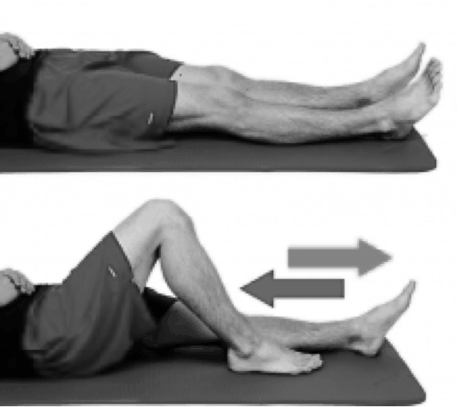 | 
I | Ice  - Ice at least 3 times/day for 20-30 minutes, combined with elevation  - Best after walking and/or exercises  - Ice right away if soreness or swelling increases | 

